SEL BIKE RODEO REGISTRATION FORM

WHAT: Bike Rodeo
WHEN: Saturday, May 21, 2016
10AM-1PM
WHERE: Greenview Upper Elementary
1825 S. Green Road, SE, Ohio

Please return the slip below to your teacher by
Monday, May16th
*children must be accompanied by an adult
Family Name:_____________________________
Address:________________________________

Child’s Name:___________________Age_______

Child’s Name:___________________Age_______

Child’s Name___________________ Age_______

Child’s Name___________________Age_______

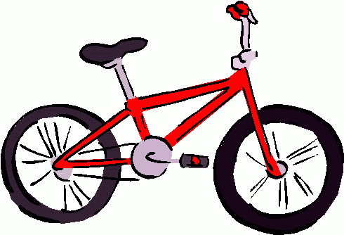
If you have any questions, please contact Lori Rodgers@216-691-2010.

